HR ANALYTICS ON JOB CHANGE OF DATA SCIENCE EMPLOYEES

GROUP - 3

FINAL REPORT

Mentored by:

MRS. VIDHYA K

Submitted by:

VIGNESH.K

MITHUN

NAVIN PRASAD

NAVIN S

ABSTRACT:

HR domain is one of the major department in every organization. The role of HR is to recruit candidates, train them, and maintain the welfare of the employees. Many HR professionals in current trend are focusing on reducing the cost and time in HR activities.HR also takes major decision in the organizational culture. Training is the major activity that involves more cost and time. There are some situations where the trained candidates quit the organization after the training period. This causes huge loss of money and time for the company. So there is a need to predict whether the employee will remain in the company after training.

The dataset is regarding the employee attrition rate from company which trains data science professionals. The objective of this dataset is to predict the attrition rate of employee.
INDEX

Sl.No | Topic | Page.No
1. | Introduction | 4
1.1 | HR Description | 4
1.2 | Uses Of Analytics In HR | 6
1.3 | Current Trends In HR | 8
1.4 | Problem Statement | 10
2. | Data Pre-processing | 11
2.1 | Data Info | 11
2.2 | Data Describe | 12
2.3 | Data Cleaning | 12
3. | Data Visualization | 24
4. | Assumption | 32
5. | Solutions Approach | 33
5.1 | Standard Scalar | 33
5.2 | Logistic Regression | 33
5.3 | Data Imbalancing | 35
5.4 | Final Model | 36
5.5 | Significant Features | 39
5.6 | Prediction Of Training Hours-Linear Regression | 41
5.7 | City Development Index | 42
6 | Interpretation | 43
6.1 | Strategy | 43

- INTRODUCTION:
Of all the departments in an organization, the Human Resource (HR)

department may have the least popular reputation.

This has two reasons. First of all, they are like a doctor: you’d rather never need one. When the HR manager calls you and asks to come by their office, it’s likely that there’s something bad about to happen. You may get reprimanded, put on notice, or even fired. If it was good news, like getting a promotion, your manager would tell you. Not HR.

Second, HR is regarded as soft. Fluffy-duddy. Old-fashioned. A lot of the work in HR is based on ‘gut feeling’. We’re doing things a certain way because we’ve always done it that way. HR doesn’t have a reputation of bringing in the big bucks or playing a numbers game like sales. HR also struggles to quantify and measure its success, as marketing and finance do.

HR analytics changes all of this. A lot of the challenges we just described can be resolved by becoming more data-driven and analytical savvy.

1.1 HR DESCRIPTION:

A company which is active in Big Data and Data Science wants to hire data scientists among people who successfully pass some courses which conduct by the company. Many people signup for their training. Company wants to know which of these candidates are really wants to work for the company after training or looking for a new employment because it helps to reduce the cost and time as well as the quality of training or planning the courses and categorization of candidates. Information related to demographics, education, experience are in hands from candidate’s signup and enrolment.

This dataset designed to understand the factors that lead a person to leave current job for HR researches too. By model(s) that uses the current credentials, demographics, experience data you will predict the probability of a candidate to look for a new job or will work for the company, as well as interpreting affected factors on employee decision.

The whole data divided to train and test. Target isn't included in test but the test target values data file is in hands for related tasks. A sample submission correspond to enrolee id of test set provided too with columns: enrolee _id, target

Note:

- The dataset is imbalanced.

- Most features are categorical (Nominal, Ordinal, Binary), some with high cardinality.

- Missing imputation can be a part of your pipeline as well.

Features:

- Enrolee id : Unique ID for candidate
- city: City code

- city_ development _index : Development index of the city (scaled)
- gender: Gender of candidate
- relevant experience: Relevant experience of candidate
- enrolled university: Type of University course enrolled if any

- education level: Education level of candidate
- major discipline :Education major discipline of candidate
- experience: Candidate total experience in years

- company size: No of employees in current employer's company
- company type : Type of current employer
- last new job: Difference in years between previous job and current job
- training hours: training hours completed

- target: 0 – Not looking for job change, 1 – Looking for a job change

1.2 USES OF ANALYTICS IN HR:

- Improved Hiring Decision

HR analytics helps HR to make better choices based on historical data. A great HR analytics tool can make a difference by enabling HR to easily derive the best candidates to hire from the historical data.

HR analytics prevent you from making such mistakes. Moreover, it also allows the recruiter to learn more about candidates through online databases, applications, social media profiles, job portals, records, etc.

- Reduced Talent Scarcity

Data-driven recruiting strategies provide the insight needed to cast a more accurate net to ultimately build a larger pipeline. With the help of HR Analytics, it is easier to know who to target for a particular position when a requirement arises in the company. It is easier to understand the type of person required, the knowledge required along with other aspects that might be missed in a regular talent acquisition process. When talent is scarce for a specific industry or role, it might seem that talent isn’t there at all. The talent is there, but finding them can be quite challenging.

- Process Improvement

Once the company has enough data to provide to the experts to come up with accurate statistics and patterns, the company can then use it to make the recruitment process much quicker and efficient. Hiring managers will know which positions in the company require what type of talent, people, background and experience, along with the type of people that will not be suitable. Then it becomes much more elementary to target a specific audience and talent pool and get much faster solutions to their challenges.

- Good Training

Training is a necessary requirement for any organization. Gaps in the process of training can increase the cost to the company and unwanted issues. Various professional development programs offered by the companies, if not handled properly, can deplete a major chunk of the company’s budget. It is highly suggested that enterprises invest in training by collecting data and learning from the pattern. HR analytics provides the full swing to training programs. It helps the

Organization identify if employees are making full use of the opportunities and knowledge given to them during training programs.

- Better Insights

HR analytics help the company look at the employee's professional life by tracking, sharing, and analyzing performance-related data. This is why companies track and record the behavior of its employees with customers, co-workers and how they spend their time. Furthermore, the employee's performance data could be used by the hiring manager to identify great talents. This data not only provides more insights about the employees but also shapes the strategies to boost employee morale, retention, and engagement.

- Attrition

When it comes to retention, HR analytics is the major tool to identify the retention rate of employees. It tells the company the reason why employees leave and why they stay. The reasons could range from under-performance, compensation, lack of skills to anything else. HR analytics could also be helpful in finding the gap areas where employees are finding difficulty in meeting goals and targets. HR can use various methods like employee surveys, team assessments, and exit and stay interviews to find out the reason for attrition and map out strategies to retain them.

- Improved Employee Experience

Once your recruitment process becomes swift, it automatically gives a good impression to candidates you want to attract to your organization. It makes the recruitment process faster and the candidates don't have to wait for weeks or months to know whether they are going to join an organization or not. This gives them a better candidate experience and improves the brand image simultaneously which gives your enterprise an edge over competitors.

- More Productive Workforce

Since enterprises have a grip on the kind of people to hire for a job, it becomes easier to expect better performance and productivity

From employees. With analytics, you get an understanding of the workforce and hence know what kind of environment, policies, and teams will make them work hard and give you results that you expect from them.

1.3 CURRENT TRENDS IN HR:

Yes, HR is about people. That will never change. But technology and HR analytics are not the enemy of people-focused management – rather they help us understand our people better.

Technology gives us unprecedented insights into the patterns and trends which shape our workforce, and our business.

Research indicates that the HR leaders of the future will be those who understand what technology can do; who know how to mine intelligent insights from the technology, and know how to apply them to their workplace to achieve their business goals.

Trend #1: The rising importance of analytics

The rise in the use of HR analytics is one of the top 10 trends in human resources, according to the report, Global Human Capital Trends 2016, produced by Deloitte Consulting and Bersin by Deloitte. The study includes responses from more than 7,000 business and HR leaders from 130 countries.

This prediction is echoed by numerous other reports, including what’s next for HR in 2016? 11 Trends from HR Leaders, by insight and technology company CEB

Trend #2: The capability gap in people analytics

While HR and business leaders understand the importance of analytics, there is a distinct lag in capacity to use it effectively.

According to the Deloitte report, 75% of companies believe that using people analytics is important, but only eight percent believe their organization is strong in this area. In fact, people analytics was

the biggest capability gap identified by Deloitte, next to good leadership.

Trend #3: Dedicated analytics positions

Many large organizations are looking to narrow this gap by hiring dedicated professionals to manage their HR Analytics.

A recent report by Price Waterhouse Coopers found that 86% of survey participants reported that creating or maturing their people analytics function is a strategic priority for the next one-to-three years. And nearly one-half (46%) of those organizations already have a dedicated people analytics function.

Well, the PWC report found that the median organization has one individual focused on people analytics per 3,567 employees.

So if it’s so time-consuming, why do organizations bother? Because HR Analytics can tell you things no one else can.

Trend #4: Beyond operations and compliance

HR Analytics isn’t new. HR leaders have been using analytical tools for years, to analyse metrics such as remuneration, absenteeism and performance and to report on operational issues.

What’s changed is the volume and quality of data collected, and the power of the analytical tools to make sense of this data.

The right HR analytics tools reveal powerful stories about what people are doing at work, who’s linking with who, who are the rising leaders.

When managed correctly, HR analytics can help you make informed decisions about:

- who, when and how to hire

- who your top performers are, and who are the leaders of the future

- hidden skillsets within your teams

- which teams are more collaborative or active or engaged than others
Trend #5: Even easy tools now give in-depth analytics

HR analytics is no longer the domain of big multinationals. Even small to medium businesses can benefit from foundational analytical tools.

Think of LinkedIn. Its reporting tools lets you who’s connected to who, which prospective talent has most connections and endorsements.

1.4 PROBLEM STATEMENT:

- Prediction of employee training hours based on experience.

- Prediction of employee attrition post training.

- Identify the main factors that influencing the employee to leave the company.

- Identify the city development index that has maximum and least employee attrition.
2. DATA PRE PROCESSING:

When we talk about data, we usually think of some large datasets with huge number of rows and columns. While that is a likely scenario, it is not always the case — data could be in so many different forms: Structured Tables, Images, Audio files, Videos etc..

Machines don’t understand free text, image or video data as it is, they understand 1s and 0s. So it probably won’t be good enough if we put on a slideshow of all our images and expect our machine learning model to get trained just by that!

In any Machine Learning process, Data Pre-processing is that step in which the data gets transformed, or Encoded, to bring it to such a state that now the machine can easily parse it. In other words, the features of the data can now be easily interpreted by the algorithm.

2.1 DATA INFO:
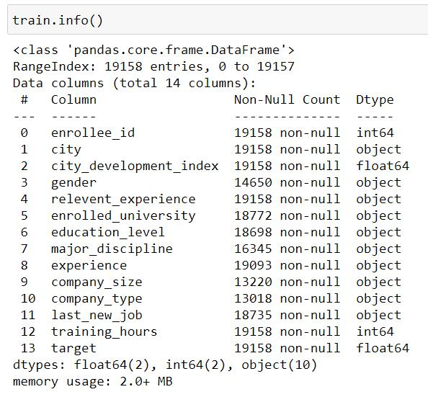

Number of Rows: 19158

Number of Columns: 14
Number of Categorical variable:

Number of Continuous variable:

2.2 DATA DESCRIBE:
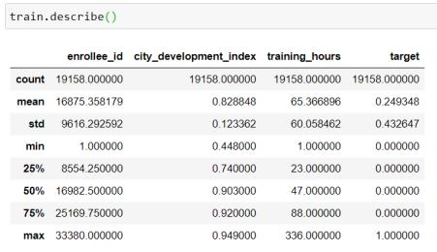

2.3 DATA CLEANING:
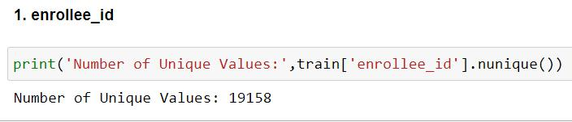

Enrolee id - all are unique values, so drop it or set it as index
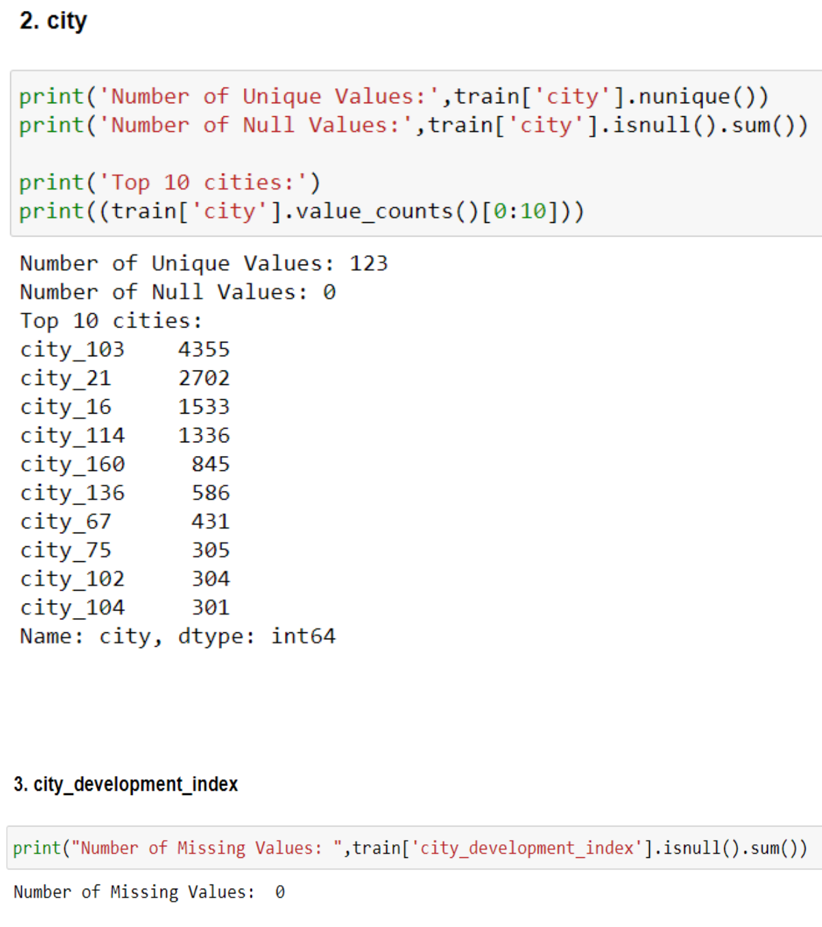
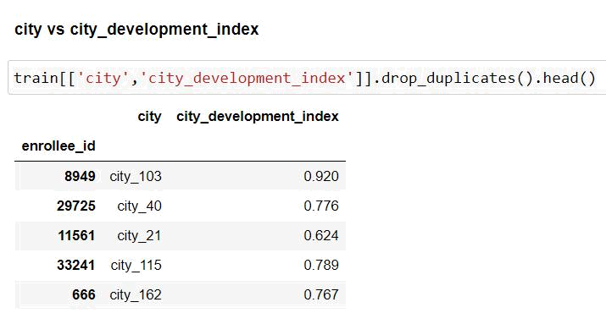

From the above, we can see that each city has specific city development index, so deleting this column won't make any difference to the model
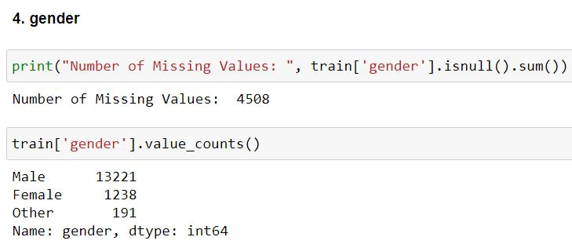
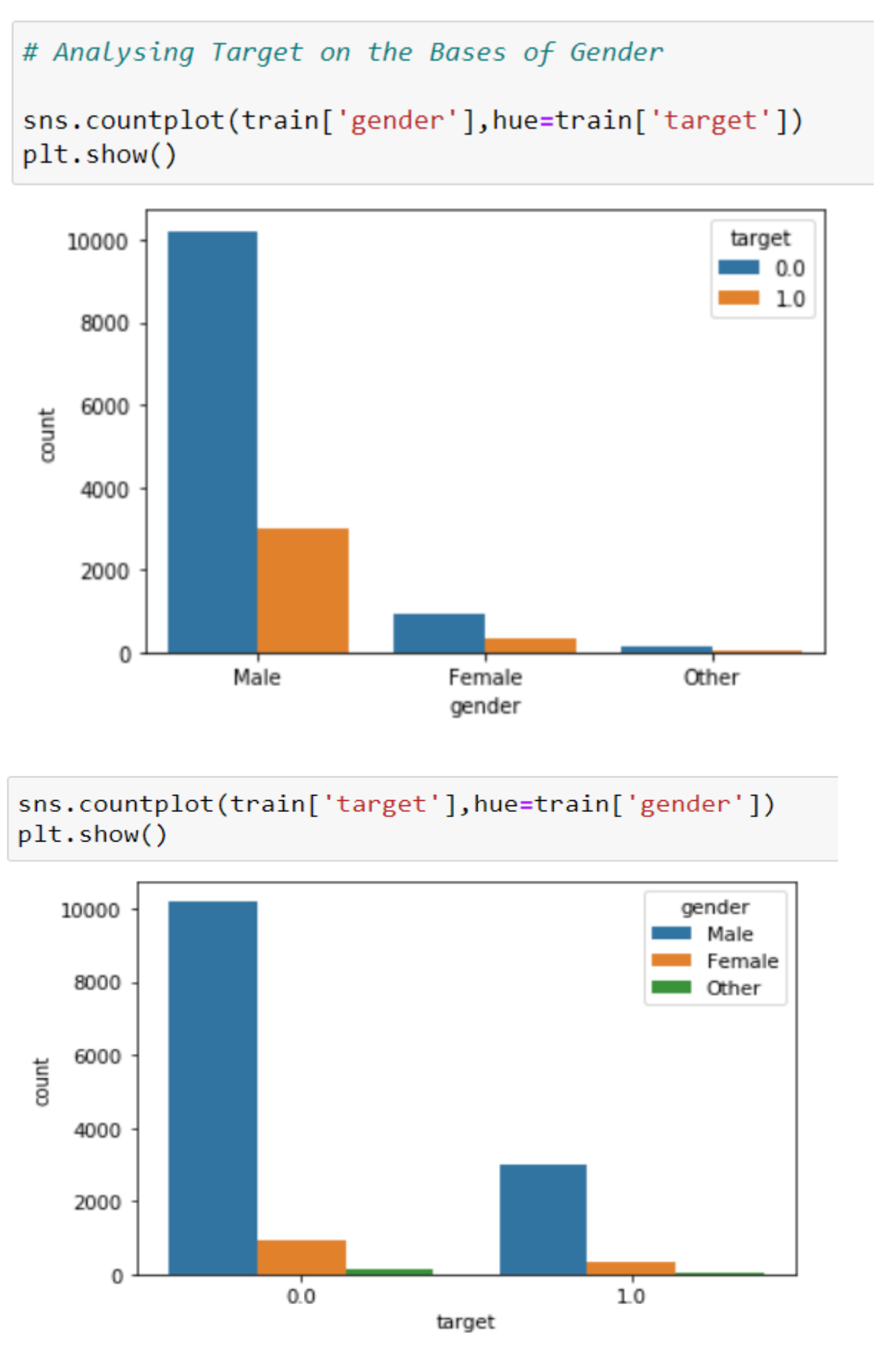

From the above, we can say that the data is gender bias as there are more number of Male

From the plot, we analyse that the percentage of males are more for Not Looking for Job Change

So we can drop the feature
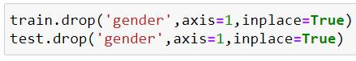
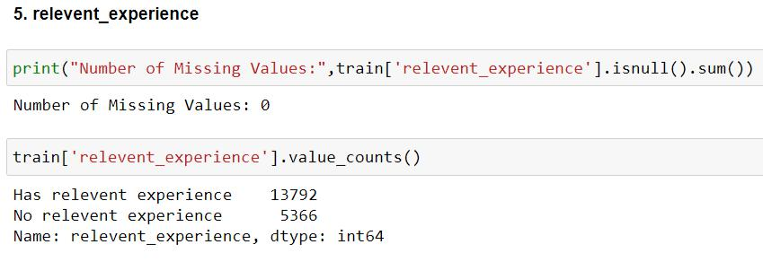
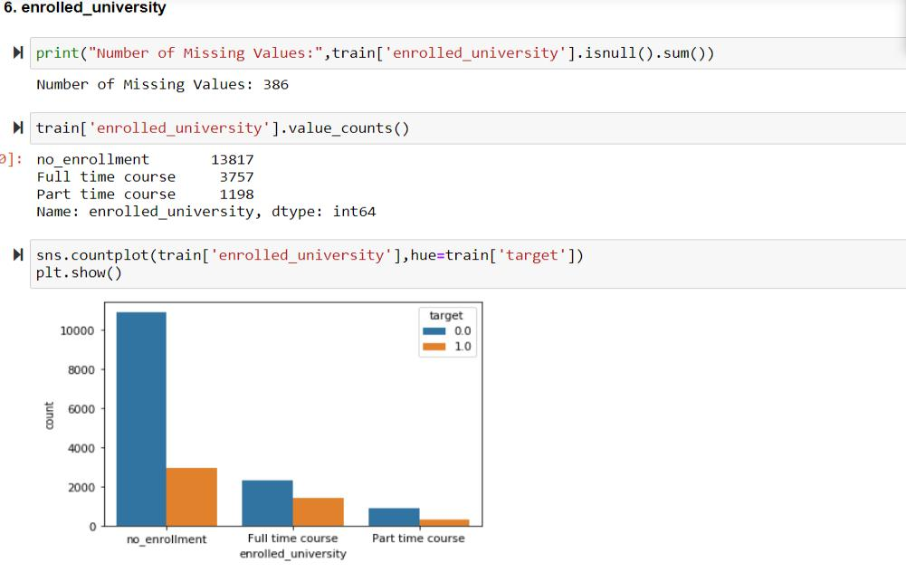

From the above, we can see that most of candidates has no enrolment are more likely not looking for a job change

- We can't assume that the missing data is left out or the candidates had no enrolment, but also we don't want to create a new value (like 'OTHER') because it can create a pattern that doesn't exist.

- So fill the missing values with the no enrolment value
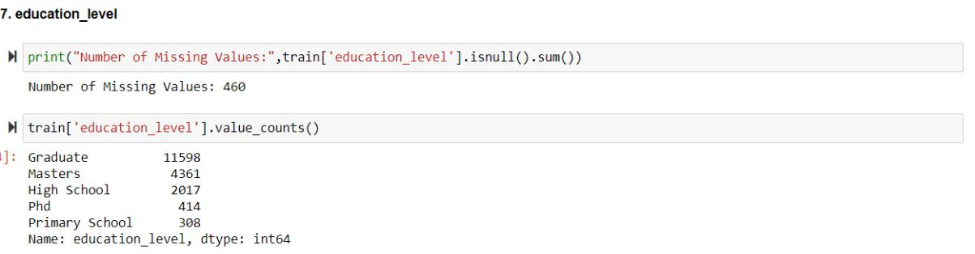

- Most candidates are graduates

- Let us consider "education level" as "Other" which are not mentioned (null values)
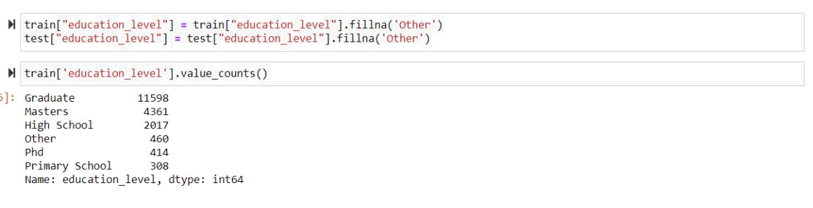
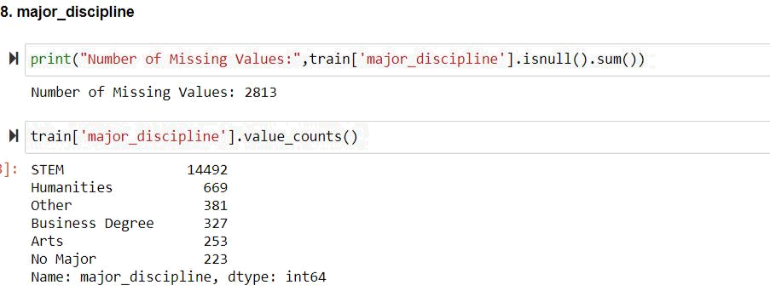

- Most of the candidates are STEM majors

- Let us consider "major discipline" as "No Major" which are not mentioned (null values)
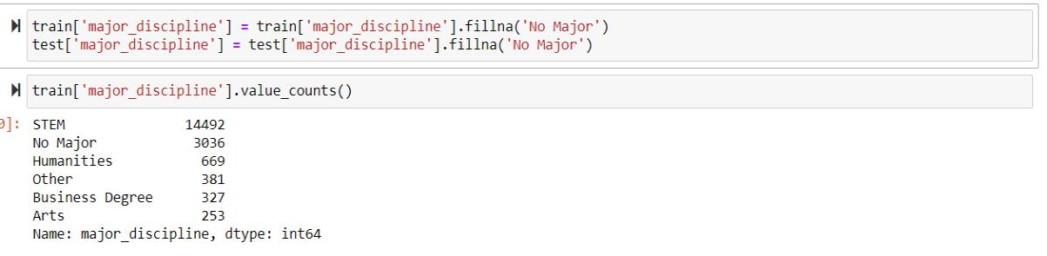
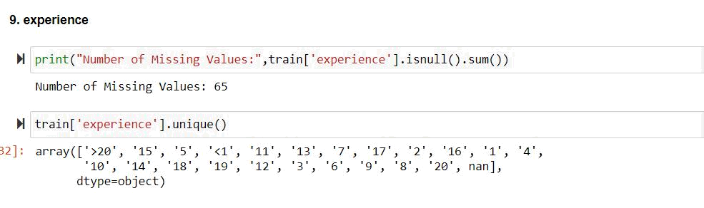

- Let us consider "experience" as "0" which are not mentioned (null values)

- The experience variable is an object indicating the minimum or maximum years of experience a candidate has, so deleting the operators won't make a big difference
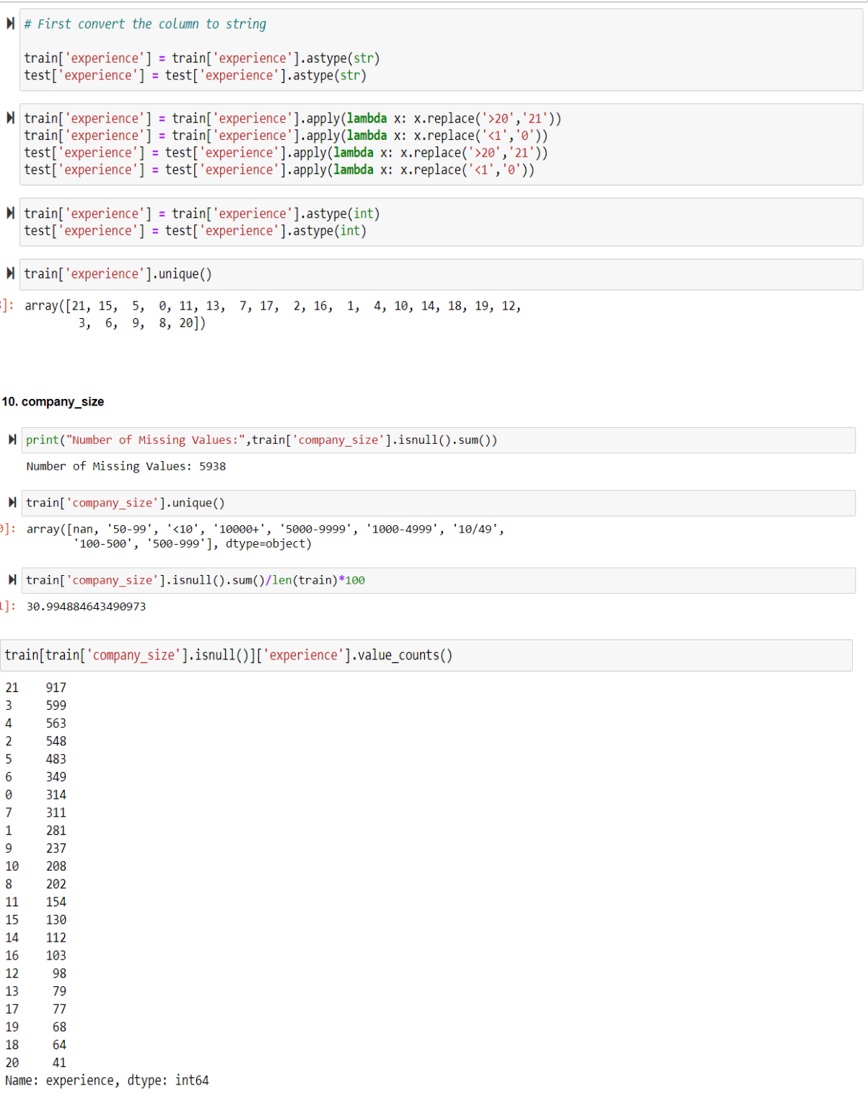

- Hence 31% of candidates didn't mention the company size but they have experience, so we will assume that these candidates has not mentioned the company size
- So fill null values as "not mentioned"
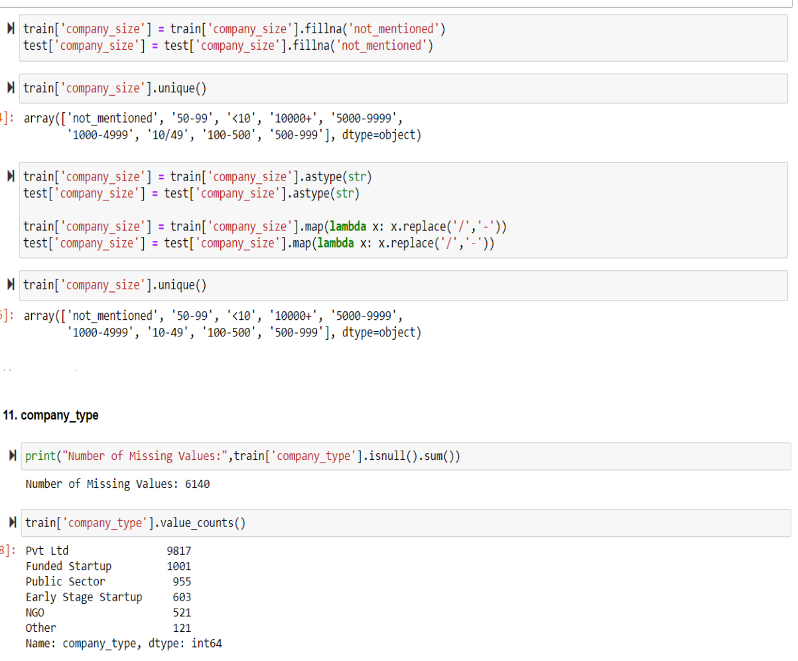

- Most of candidates work in Private limited company type (pvt ltd)
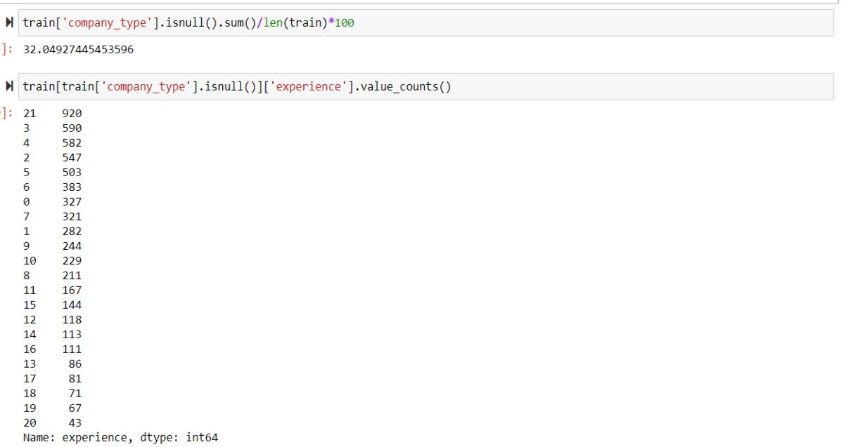

- Hence 32% of candidates didn't mention the company type but they have experience, so we will assume that these candidates has not mentioned the company type

- So fill null values as "not mentioned"
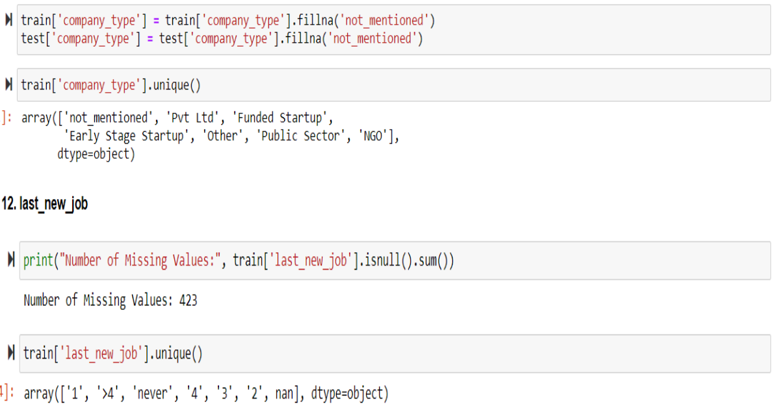

- Let us consider the missing values are from candidates whose has no job
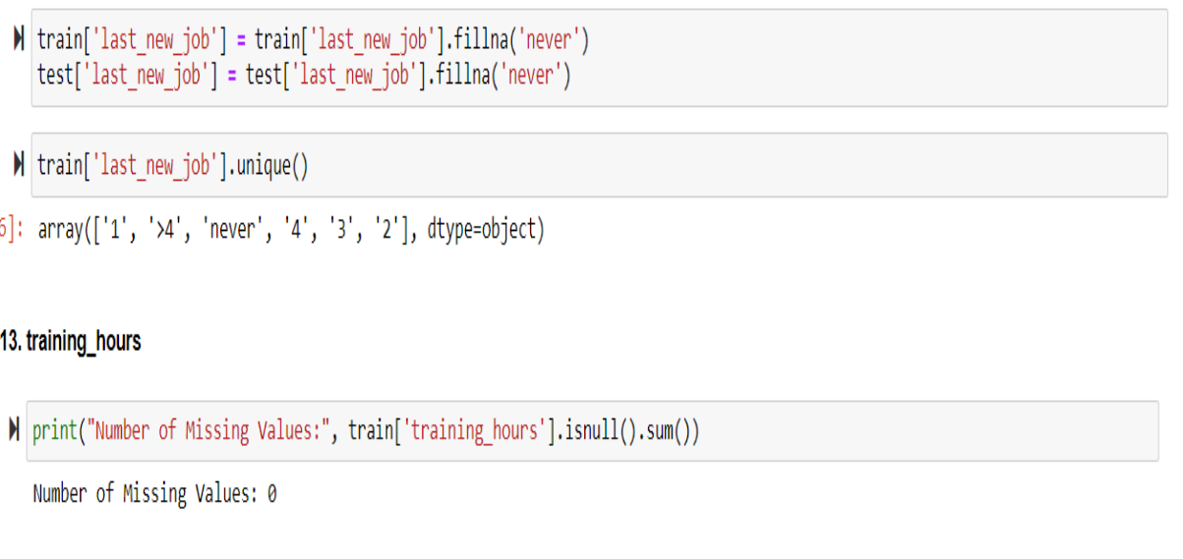
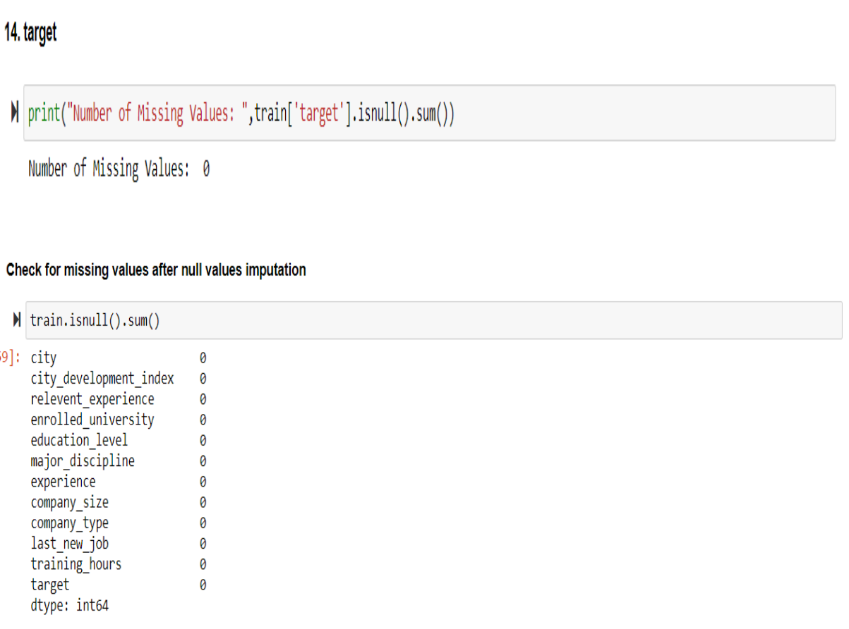

- Data Visualization

- Gender Vs. Target
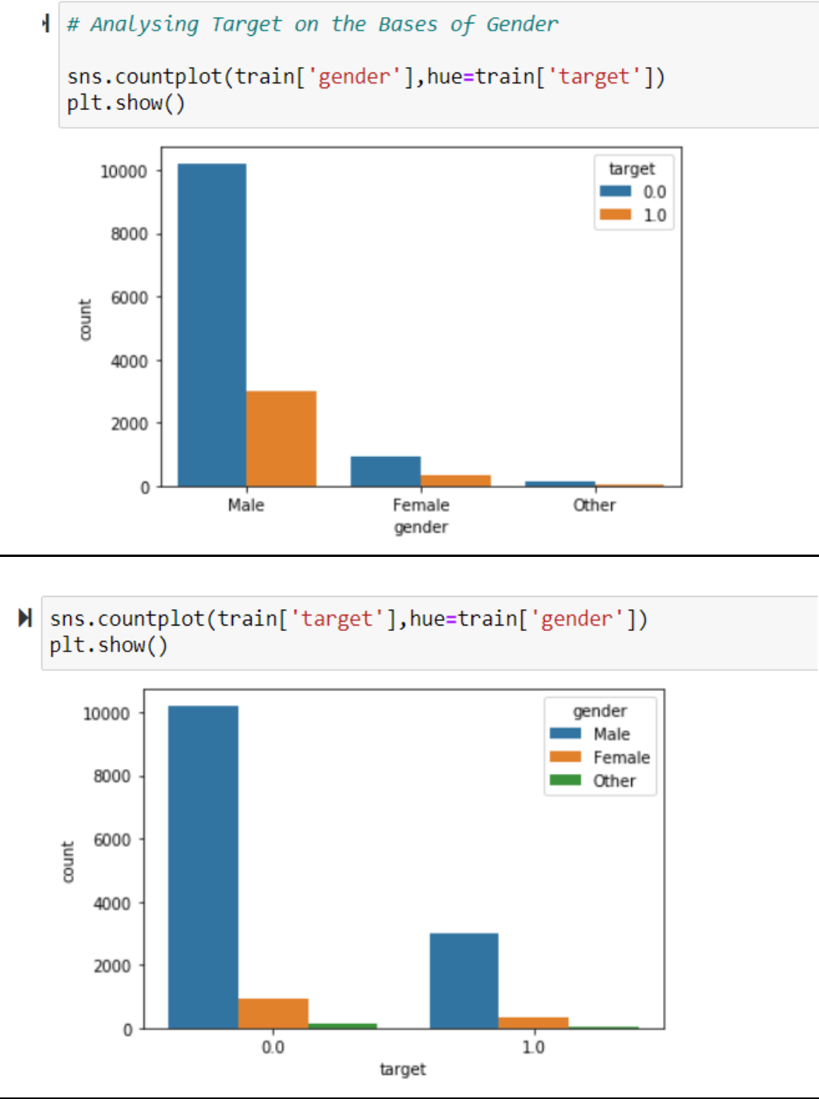

- Inference: From the above, we can say that the data is gender bias as there are more number of Male

- From the plot, we analyse that the percentage of males are more for Not Looking for Job Change

- So we can drop the feature
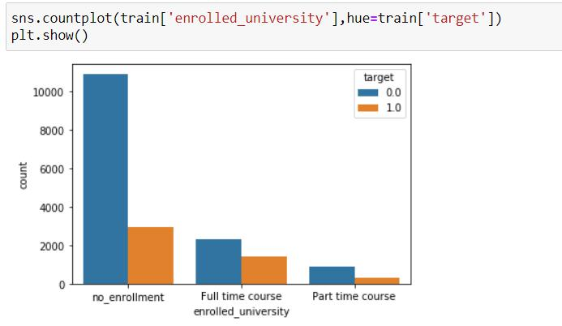

- Inference: Most of candidates has no enrolment are more likely not looking for a job change

- We can't assume that the missing data is left out or the candidates had no enrolment, but also we don't want to create a new value (like 'OTHER') because it can create a pattern that doesn't exist.

- So fill the missing values with the no enrolment value
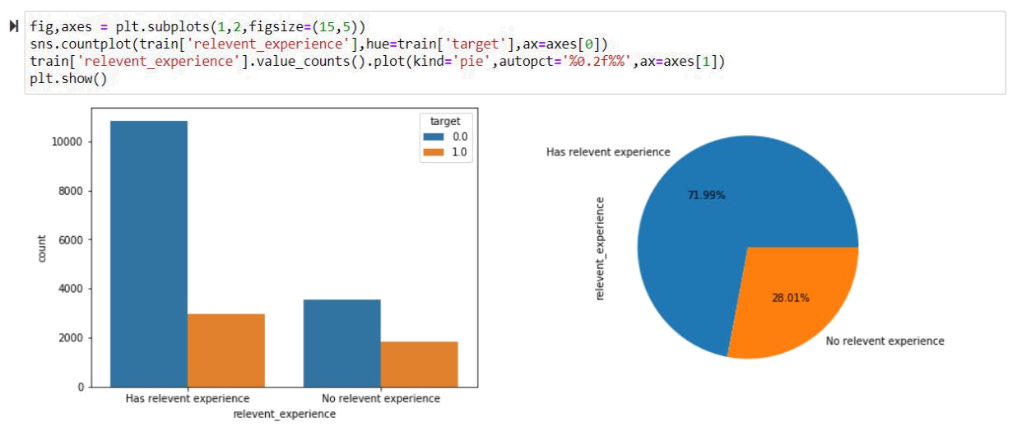

- Inference: Most of the candidates has relevant experience

- Candidates with relevant experience are not looking for a job change
- Candidates with no relevant experience are more keen to change job

- 72% employees has relevant experience and around 11k employees are not looking for job change.
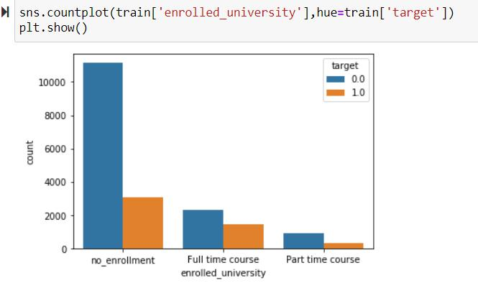

- Inference: Most of the candidates are having no enrolment in any university and those without any enrolment have no interest in changing their job

- Part Time course enrolled candidates are very less and they also don't want to change

- Full time enrolled are not very much looking for jobs but in proportion they have higher chance of changing the job than others.
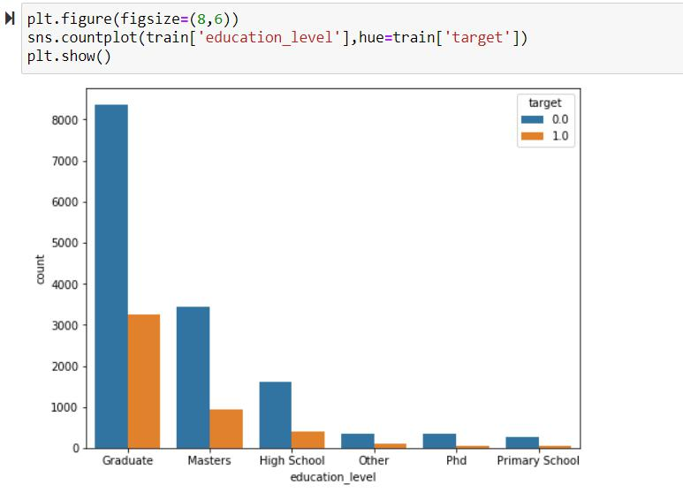

- Inference: Graduates have very less chance of leaving
- In every education level, there is a very less chance of changing job.
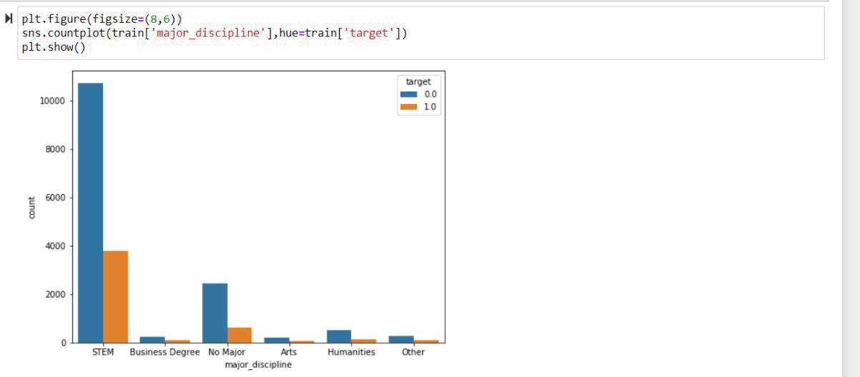

- Inference: Mostly candidates are STEM and not looking to change the job in any discipline.
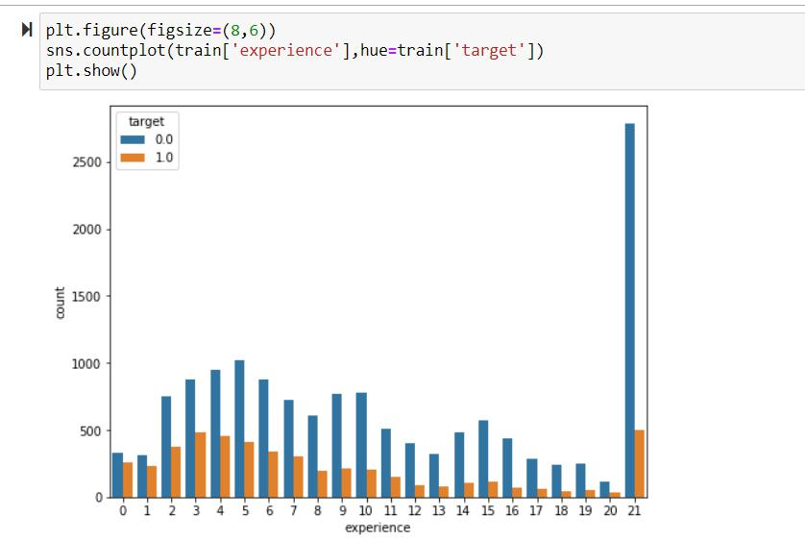

- Inference: Candidates who have experience less than 1 year have more tendency to change their job while those with more than 20 years of experience have very less tendency of changing jobs
- As experience increases, tendency to change the job becomes less.
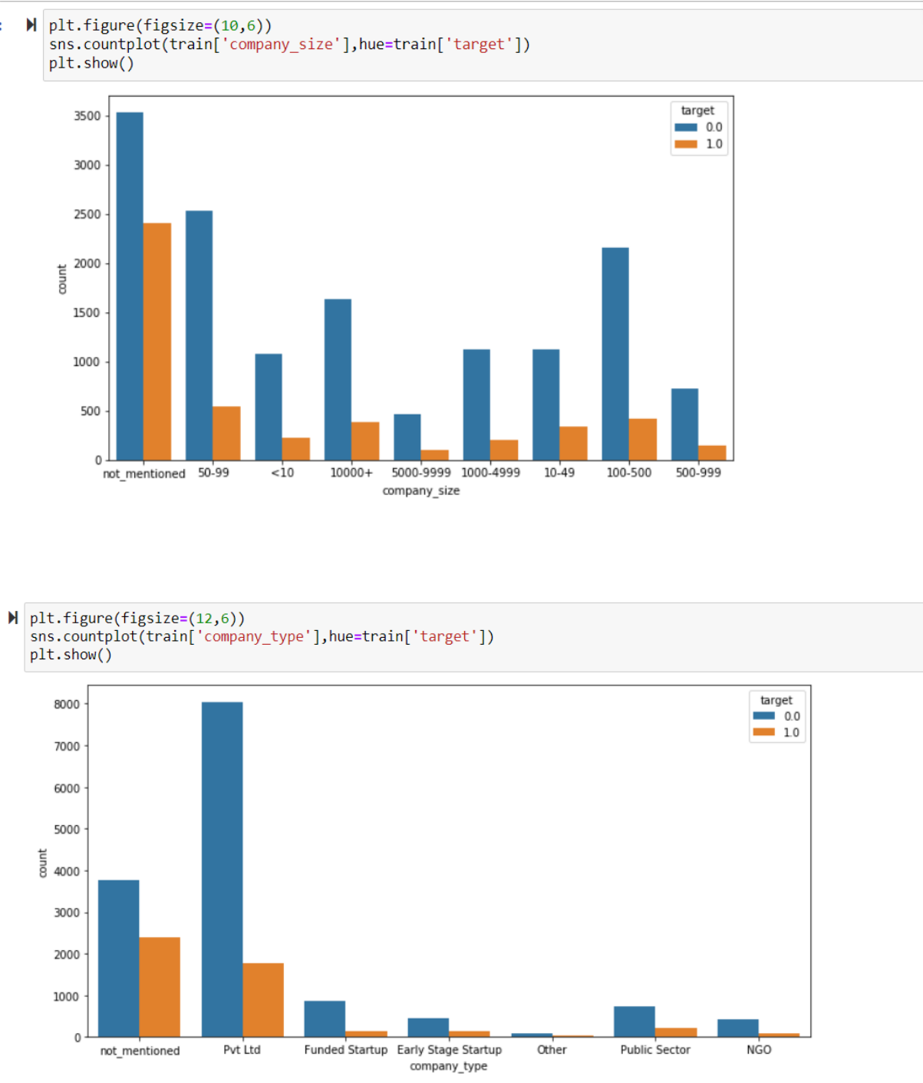

- Inference: All company type shows candidates do not leave the company after training
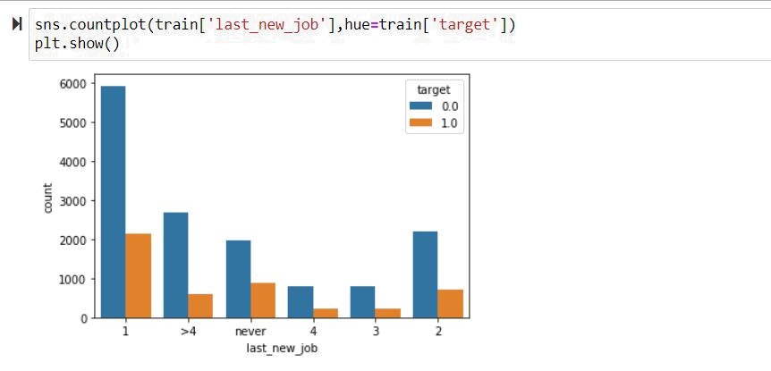

- Inference: So , probability is higher that a person will not change job

- From the above two plots, we can see that data is imbalance and there are approx. 75% of employees who are not looking for job change
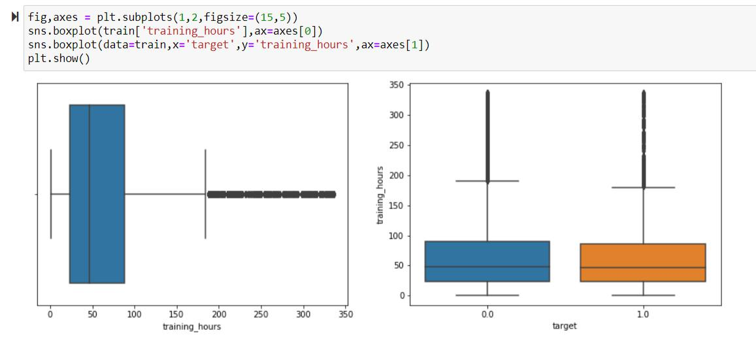

- Inference: From the plot, we can see that the number of hours used to train a candidate don't actually contribute a lot to the decision to change the fields for the candidate

- There is no much difference between training hours of those who are wishing to change and those who are not.
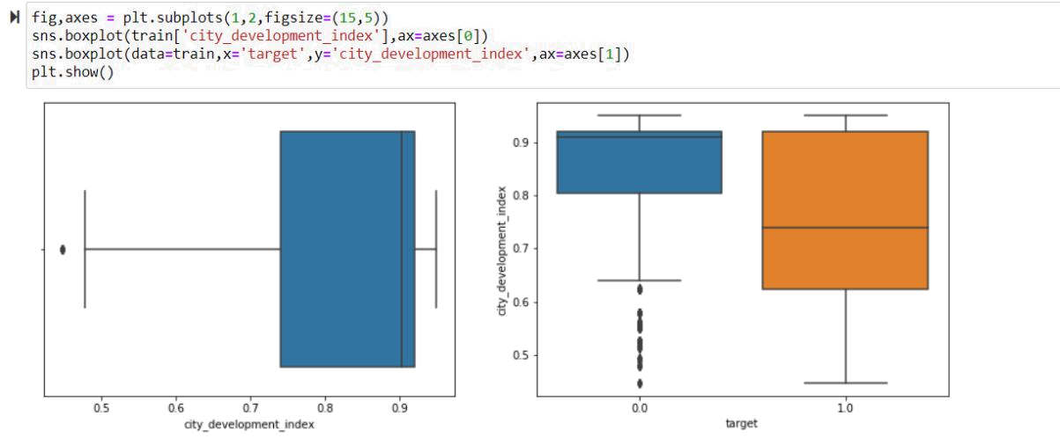

- Inference: Most of the people who are not changing jobs are from city with high development index so basically they are having a comfortable life in respective city are not willing to change jobs

- People in cities with less development index looks to change their jobs maybe for better life style
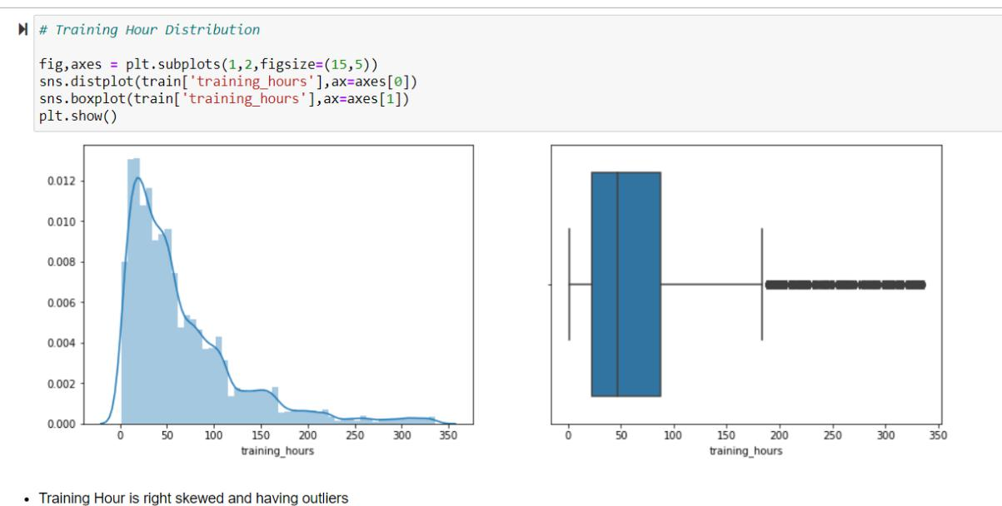

- Inference: Training Hour is right skewed and having outliers.
- Assumptions

1. KNN: KNN is one algorithm in supervised learning for classification. This algorithm works based on distance. Based on distance the algorithm finds nearest neighbours. This algorithm is also used for regression. There are three distance metrics to measure the distance.
The steps in KNN algorithm are:

  - Select the no. of. neighbours.

  - Find the distance based on the neighbours.

  - Select the neighbours based on the distance.

  - Count the observation in each category and allocate the new data to clusters having max no.of.data.

- Random Forest Classifier: Random forest classifier is one of the technique in ensembling technique. Ensembling is process of making final decision by accumulating multiple individual decision trees. In random forest base learners are always decision tree. Random forest is an independent model. In random forest both row and column is used to construct decision tree. Row sampling is taking some samples out of no.of.rows and column sampling is constructing decision tree from the samples. The hyper parameters are estimators which is no.of.trees, max samples which is percentage of samples in each bag, max_feature which is no.of.columns.

- Solutions Approach

The main problem statement is predicting whether the employee will stay in the company after training.

The Supervised Learning Classification techniques can be used to solve the problem statement.

5.1 Standard Scalar
Standard scalar used to bring average value in the range between 0and 1 and standardisation of data.

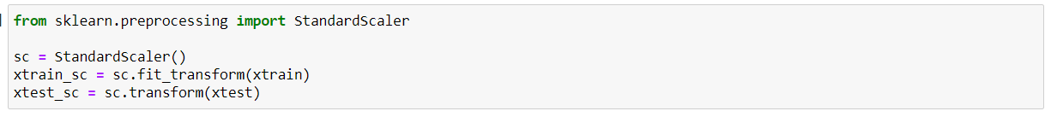

5.2 Prediction Of Employee Attrition-Logistic Regression
Logistic Regression is used to produce prediction in binary format.Logistic Regression comes under Supervised learning classification.The base model is built using this model.The logistic model is built to predict the employee attrition after training.

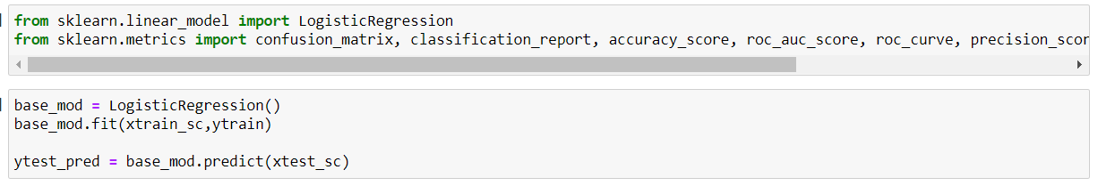

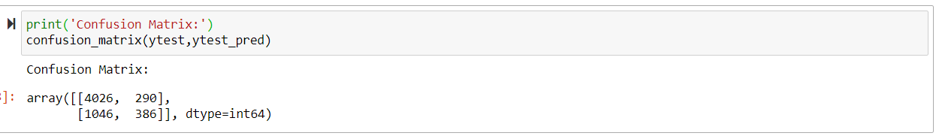

The confusion matrix is one of the key metrics in classification.It is used to measure how well the model works.

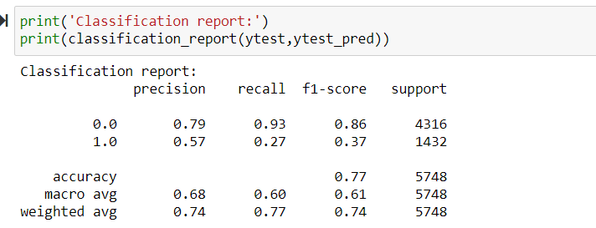

The classification report gives the summary of precision, recall, f1_score, support. The accuracy of the model is also shown in this report.

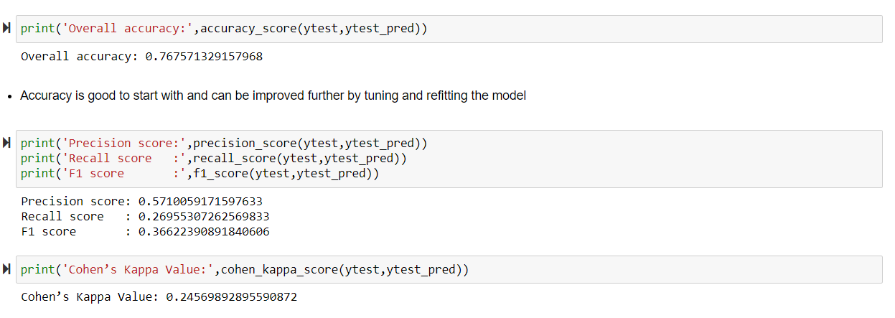

- The overall accuracy score is 0.76 which is not too bad but few other tuning techniques can be used to improve the accuracy score.
- The precision score is 0.57 which is used to show absolute positive values to total positve values.
- The recall score is 0.26 which is similar to precision score in way that it tells the count of postive values.
- The cohen’s kappa value is 0.24 which is used to evaluate the classification model.
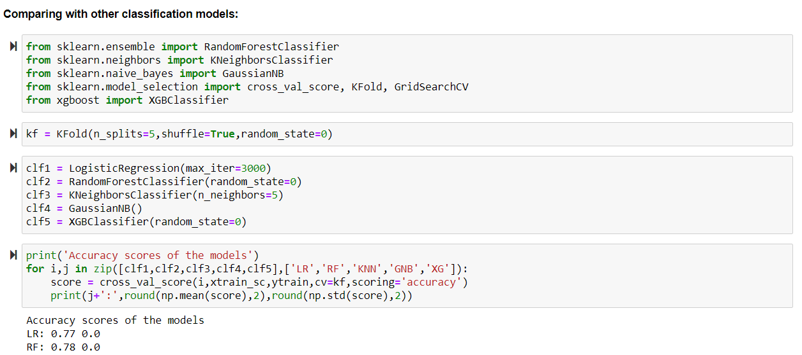

The model is refitted and then built with various logistic regression algorithms.The varoius algoritms used are random forest classifier which shows 0.78 accuracy, logistic regression which shows 0.77.

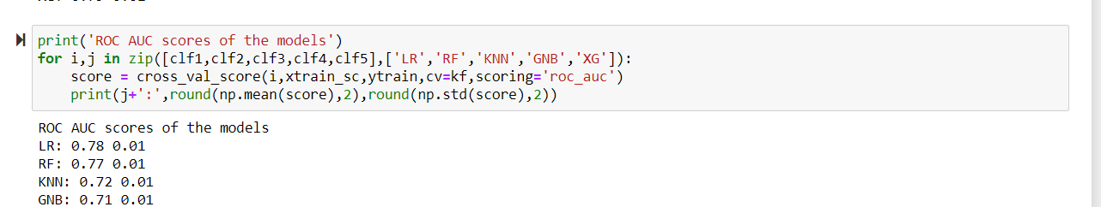

The roc curve is also built in this model.The roc curve values for logistic regression is 0.78, random forest is 0.77,KN Neighbors is 0.72,XG boost is 0.71.

5.3 Data Imbalancing

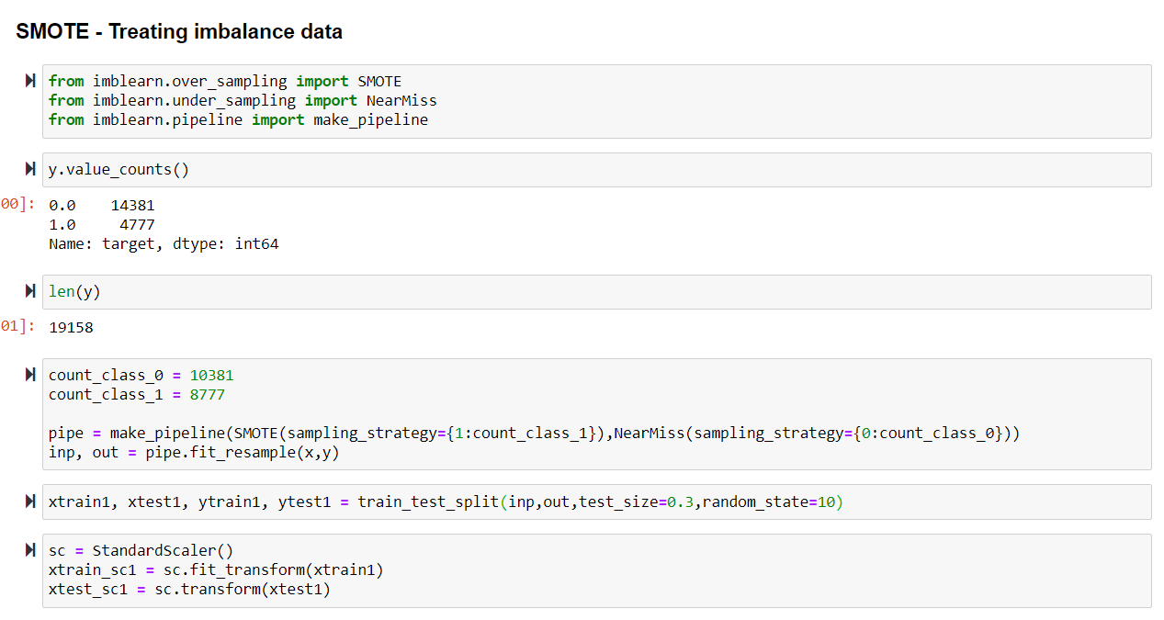

The SMOTE is used to treat the imbalanced data.The pipleline method is used to balance the data.After the data is balanced the standard scalar is built again to standardise the data.

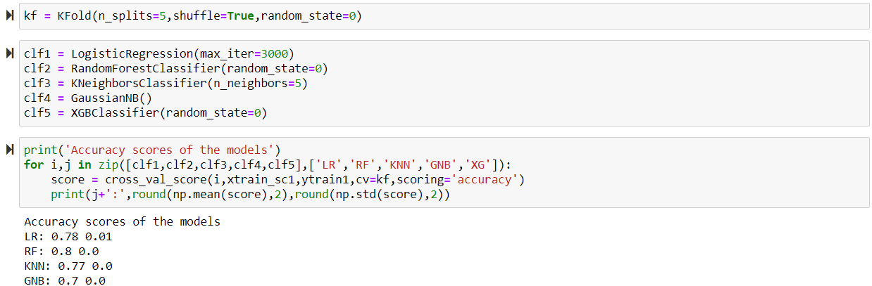

- The logistic regression is built again after balancing the data.Now the accuracy is 0.78 for this model.
- The Random Forest is built again after balancing the data.Now the accuracy is 0.8 for this model.
- The KN Neighbors is built again after balancing the data.Now the accuracy is 0.77 for this model.
- The XG Booster is built again after balancing the data.Now the accuracy is 0.7 for this model.

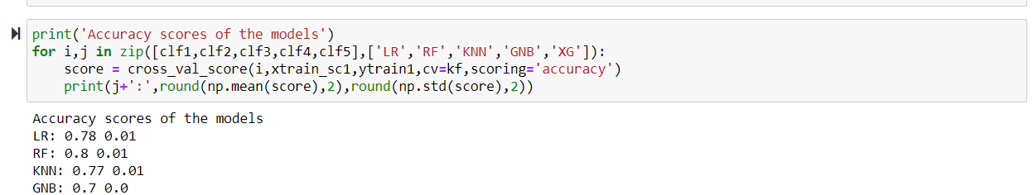

The roc curve is also built after the data is balanced.The roc curve values for logistic regression is 0.78, random forest is 0.72,KN Neighbors is 0.72,XG boost is 0.7

5.4 Final Model
After comparing all the algorithm based on the accuracy score we came to know that XG Boost is the best model to predict employee attrition.

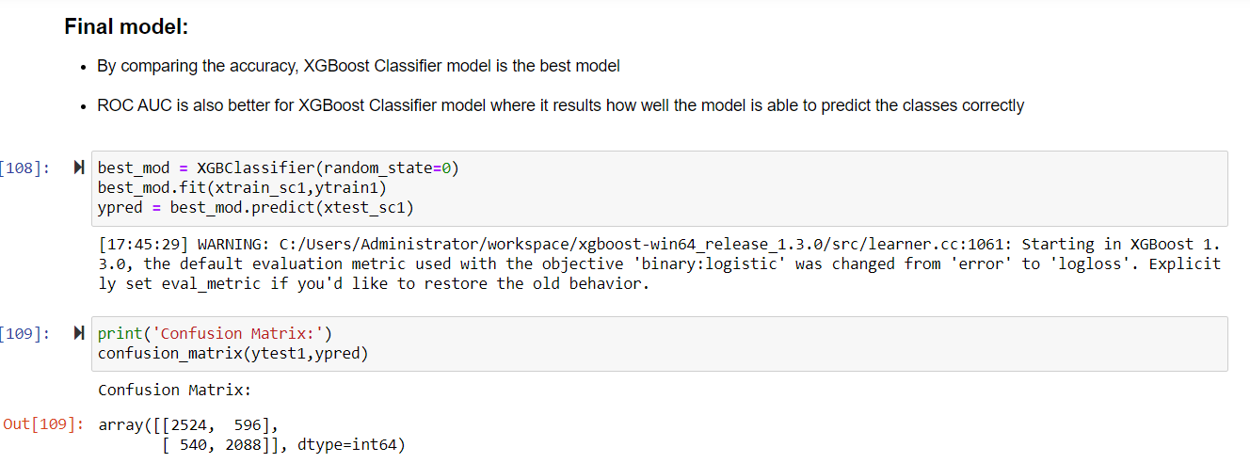
The confusion matrix is again executed to check perfection of the model after the data is balanced.

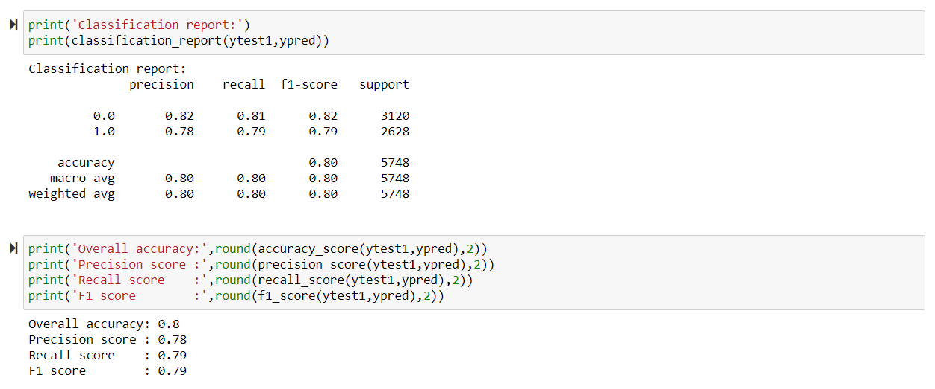
The classification report gives the summary of precision, recall, f1_score, support. The accuracy of the model is also shown in this report. The classification report is executed again to check the difference after the data is balanced.

The overall accuracy is 0.8,precision score is 0.78,recall score is 0.79,f1_score is 0.79 in the final model.

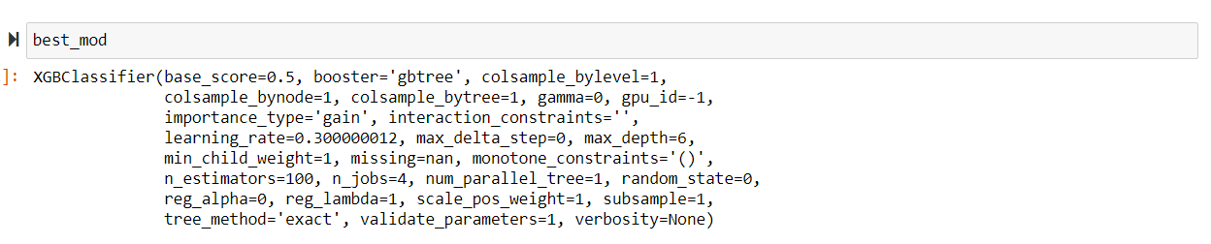
Tuning Hyperparamaters

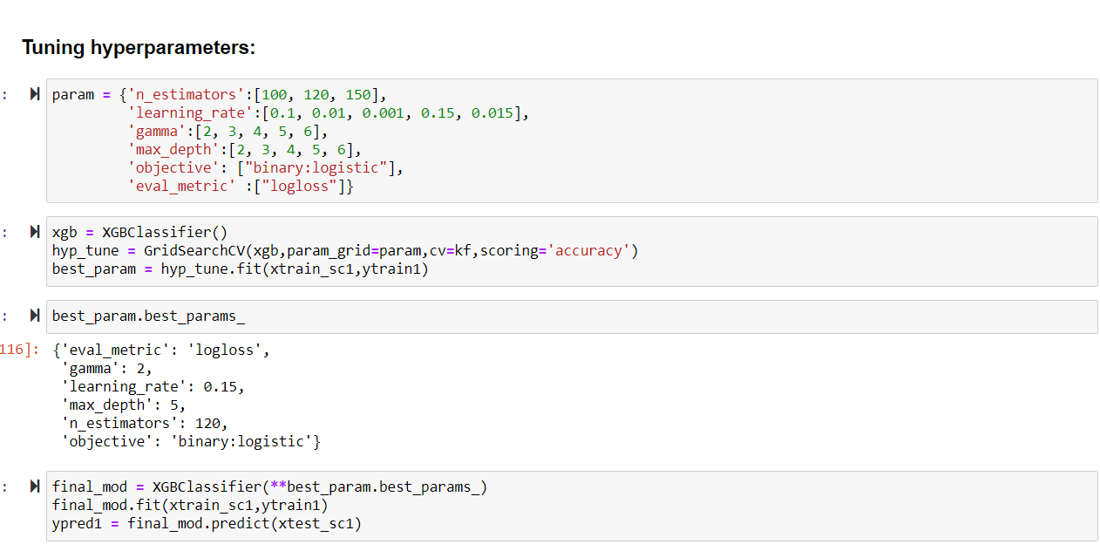
The parameters are tuned to fit the model.The gamma value is 2, learning_rate is 0.15, n_estimators is 120.
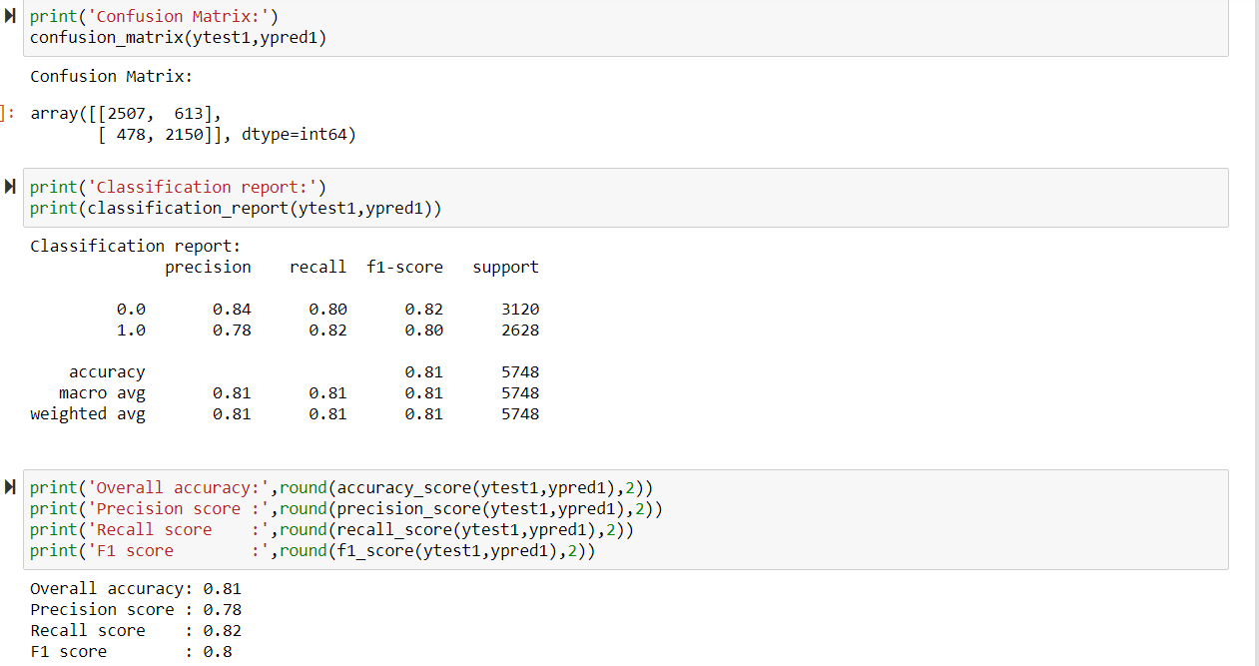
- The confusion matrix is again executed to check perfection of the model after the parameters is tuned.
- The classification report gives the summary of precision, recall, f1_score, support. The accuracy of the model is also shown in this report. The classification report is executed again to check the difference after the data is balanced.
- The overall accuracy is 0.81,precision score is 0.78,recall score is 0.82,f1_score is 0.8 in the tuned model.

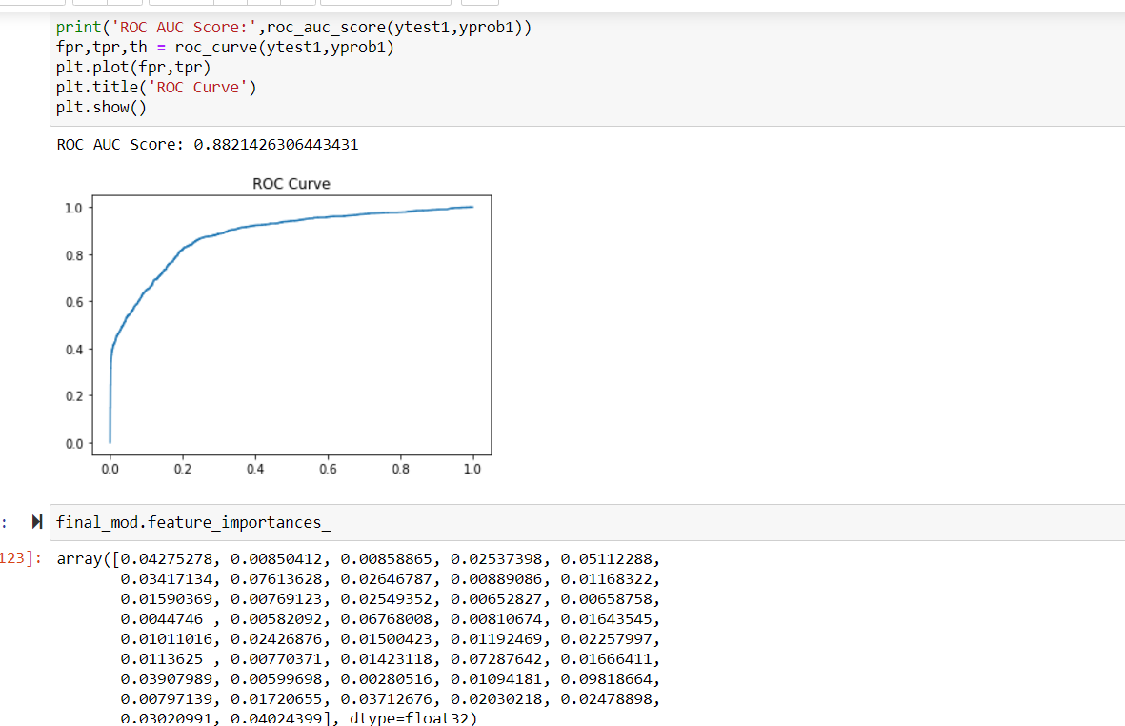
The ROC curve is also built after the parameters are built.

5.5 Significant Features

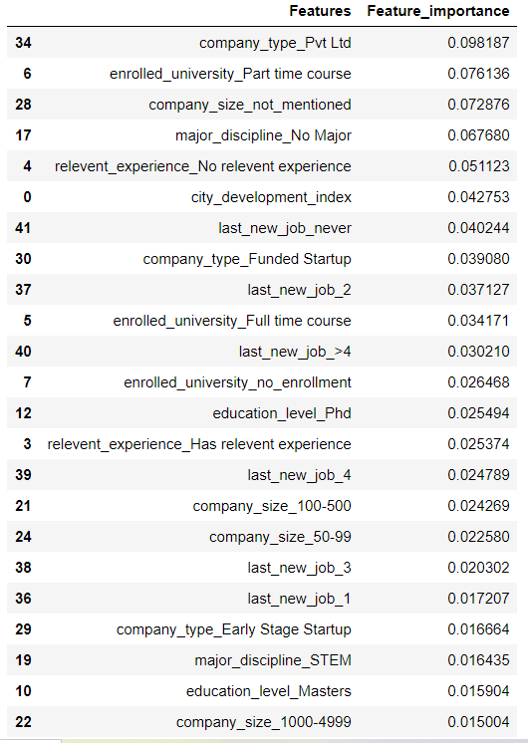

The features mostly impacting target variable is company_type_pvt_ltd, enrolled_university_Part_time_course,company_size_not_mentioned, major_discipline_No_Major,relevant_experience_No_relevant experience, city_development_index,last_new_job_never,company_type_funded startup,last_new_job_2,enrolled_university_full_time_course, last_new_job>4,company_size_100-500,company_size_50-99,last_new_job_3,last_new_job_1,company_type_early_stage_startup, major_discipline_STEM,education_level_masters,company_size_1000-4999.

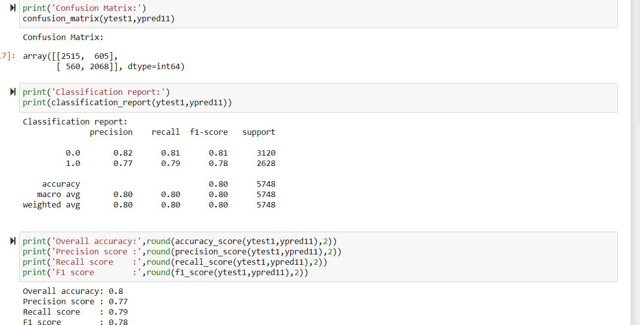

The model is built using 6 most impacting features and found to be 0.80 accuracy.

5.6 Prediction Of Training Hours-Linear Regression
The linear regression model is used to predict the training hours using other factors.

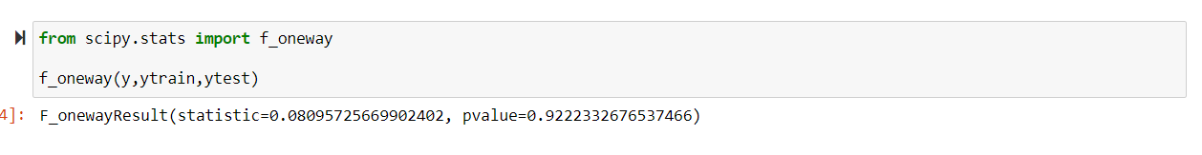
From one way test we can infer the model is insignificant.
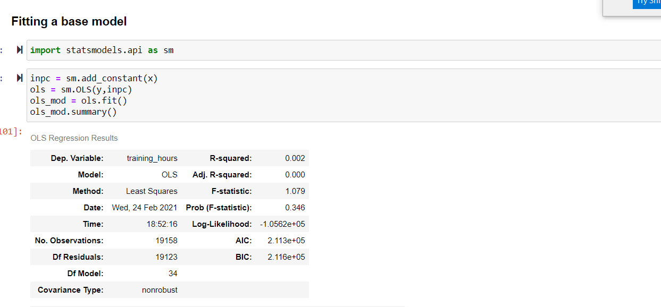
We have builted the base model and found the r square value to be less than 0.05
Inorder to improve the model we have done muticollinearity and partial scaling and then omitted the unwanted columns after that we have again builted the model.
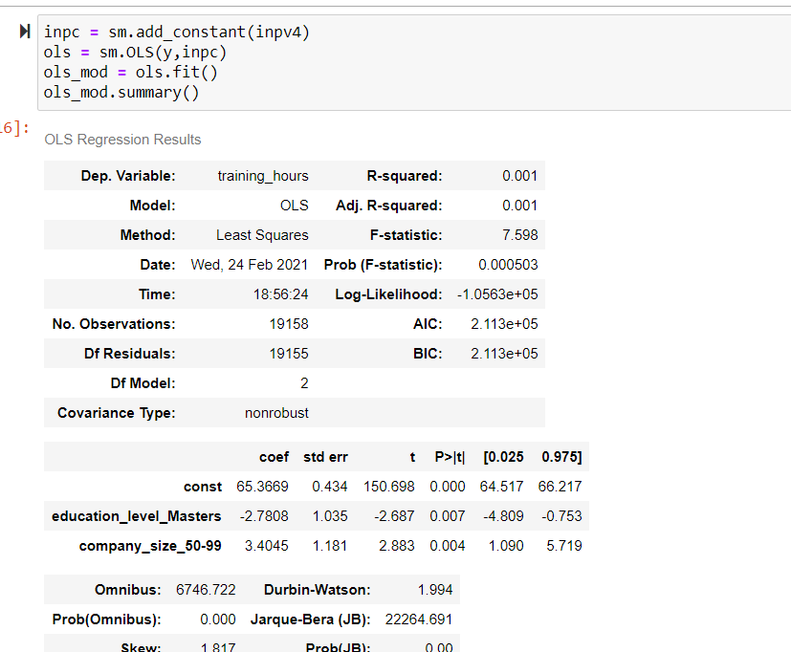

From the above model as a whole we can say that training hours is not depend on any features.

5.7 City_Development_Index

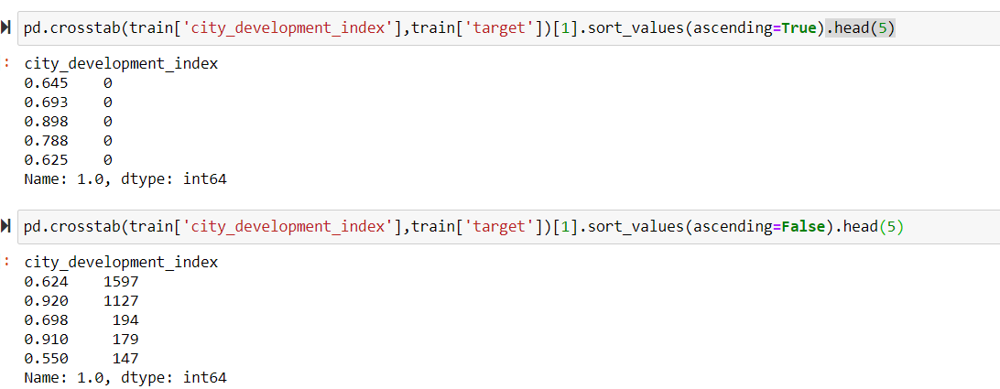

The employee attrition is 0 for citys having development index of 0.645, 0.693,0.898,0.788,0.625 and max of 1597 for the city having development index of 0.624.
6.Interpretation
- From the whole inferences we can say that employee retention is more than employee attrition when tested with all the factors.
- The private companies has most impact on the model.

6.1 Strategy
- Employee requirement can be collected before training process.
- Employee can be rewarded based on the performance during training.

